Git vs GitHub

* **What is Git ?**

Git is a distributed version control system (VCS) that is widely used for tracking changes in source code during software development. It was created by Linus Torvalds, the same developer who created the Linux operating system kernel, in 2005. Git is designed to be fast, efficient, and scalable, making it suitable for both small projects and large, complex ones.

Top of Form

* **What is features of Git ?**
* **Version Control**: Git tracks changes to files over time, allowing developers to revert to previous versions, compare changes, and collaborate on projects effectively.
* **Distributed**: Unlike centralized version control systems, Git is distributed, meaning every developer has a complete copy of the repository, including its entire history. This allows for offline work and facilitates collaboration without the need for a central server.
* **Branching and Merging**: Git uses branches to isolate work in progress from the main codebase. Developers can create, switch between, and merge branches easily, enabling parallel development and experimentation without affecting the main codebase.
* **Commit**: A commit in Git represents a snapshot of changes to the repository at a particular point in time. Each commit has a unique identifier (hash) and includes metadata such as the author, timestamp, and a commit message describing the changes.
* **Remote Repositories**: Git supports remote repositories, allowing developers to collaborate with others by pushing and pulling changes to and from shared repositories hosted on platforms like GitHub, GitLab, or Bitbucket.
* **Pull Requests**: In a collaborative workflow, developers propose changes to a shared repository by creating pull requests. This allows team members to review, discuss, and approve changes before they are merged into the main codebase.
* **Merge Conflict Resolution**: When changes made by different developers conflict with each other, Git helps resolve conflicts by highlighting the conflicting sections and allowing developers to manually reconcile the differences.
* **Tagging**: Git allows developers to create lightweight or annotated tags to mark specific points in history, such as release versions or milestones.

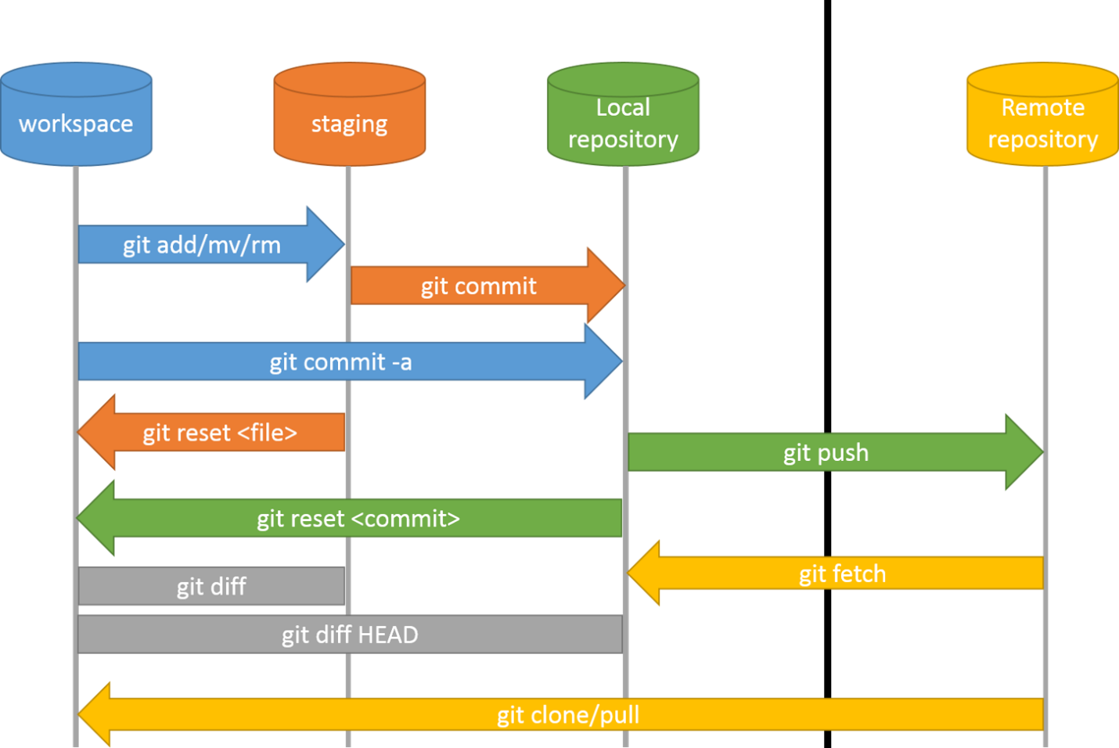

Overall,Git provides a powerful and flexible platform for version control, enabling efficient collaboration, tracking of changes, and management of software development projects.

* **what is Github ?**

GitHub is a web-based platform and service that provides hosting for software development projects using the Git version control system. It offers a range of features that facilitate collaboration among developers, project management, and code hosting.

1. **Code Hosting**: GitHub allows developers to host their Git repositories on its platform. Users can create public or private repositories to store, manage, and collaborate on code with others.
2. **Collaboration Tools**: GitHub provides a range of collaboration tools, including pull requests, issues, and project boards. These tools enable developers to propose changes, discuss ideas, report bugs, and track tasks within the context of their projects.
3. **Pull Requests**: Pull requests (PRs) are a key feature of GitHub that facilitate code review and collaboration. Developers can create pull requests to propose changes to a repository and request feedback from collaborators. PRs provide a platform for code review, discussion, and iteration before changes are merged into the main codebase.
4. **Issues**: GitHub's issue tracking system allows developers to report bugs, request features, or discuss ideas related to a project. Issues can be assigned, labeled, and categorized to facilitate organization and prioritization.
5. **Project Management**: GitHub provides project management features such as project boards, milestones, and kanban-style task boards. These tools help teams organize and track their work, manage deadlines, and visualize the progress of their projects.
6. **Wiki and Documentation**: GitHub allows users to create and maintain project wikis and documentation directly within their repositories. This makes it easy to document project information, guidelines, and procedures alongside the codebase.
7. **Code Review**: GitHub provides built-in code review features that allow collaborators to review proposed changes, provide feedback, and suggest improvements. Code reviews help maintain code quality, identify potential issues, and ensure consistency across contributions.
8. **Integration and Automation**: GitHub integrates with a wide range of third-party services and tools, including continuous integration (CI) systems, code quality analysis tools, and project management platforms. This enables developers to automate workflows, streamline development processes, and enhance productivity.
9. **Community and Social Features**: GitHub fosters a vibrant developer community by providing features such as social networking, following other users and projects, and showcasing contributions through user profiles and activity feeds.

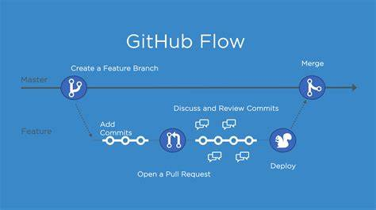

Overall, GitHub serves as a central hub for software development projects, offering a comprehensive set of tools and features to support collaboration, code management, and project coordination. It has become an essential platform for open source development, enterprise software projects, and individual developers alike.

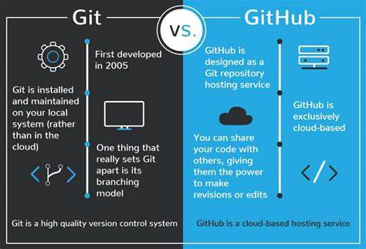

Thank you